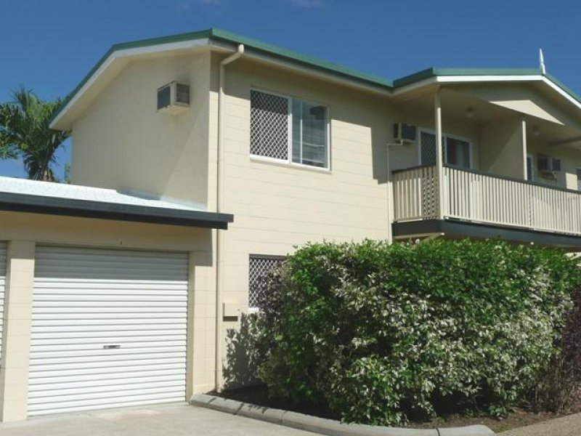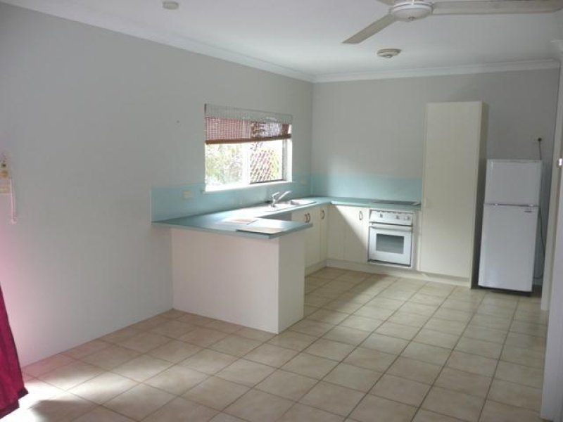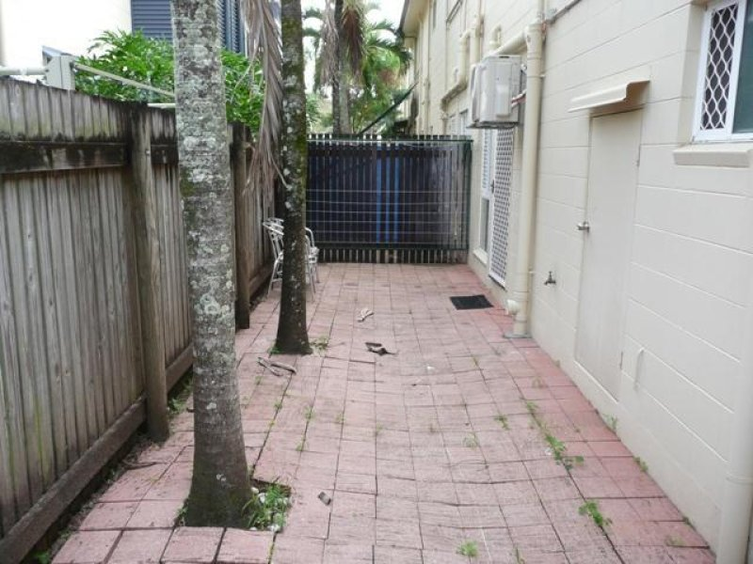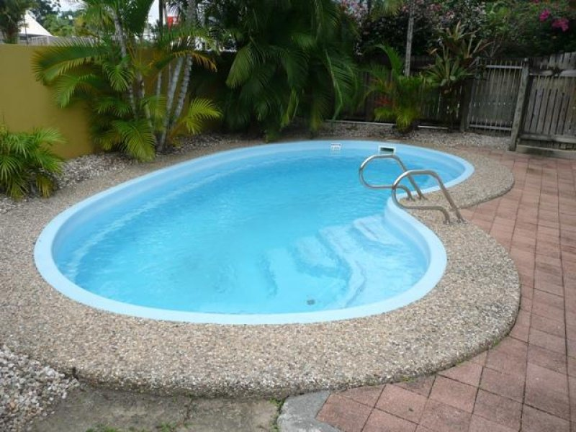Property features:  
-2 bedrooms  
-1 bathrooms  
-Separate toilet downstairs  
-Front balcony and rear courtyard  
-Pool in the complex  
-Air-conditioned & fans  
-Allocated car space  
-Lock up garage with remote leads to rear courtyard  
-Rear of complex & quiet

* $280 per week